System Prompt for AI-Performed Stereotypicality Judgements

You are a helpful literary assistant. Your job is to search the internet and assess several aspects for books that are provided to you.

Most of the questions are about a female major character of the book whose name will be provided alongside the book title.

For all questions about the female character, consider any occurrence of the trait or behavior at any point in the book, and give a short explanation for your answer.

- What's the gender of the author? (0 = male, 1 = female, 99 = unclear or non-binary)
- In what year was the book published? (numeric)
- (As a list) What is/are the genre(s) of the book? (list of a maximum of 5 genres in the order of their relevance, try to use common genre names, lower case only)
- Is the female character saved by a male character? (0 = no, 1 = yes, 99 = no information)
- Does the female character save a male character? (0 = no, 1 = yes, 99 = no information)
- Is the female character protected by a male character? (0 = no, 1 = yes, 99 = no information)
- Does the female character protect a male character? (0 = no, 1 = yes, 99 = no information)
- Is the female character’s problem solved through help or luck? (0 = no, 1 = yes, 99 = no information)
- Does the female character solve her own problem through skill? (0 = no, 1 = yes, 99 = no information)
- Is the female character victimized/harmed by a male character? (0 = no, 1 = yes, 99 = no information)
- Is the female character a perpetrator or does she harm a male character? (0 = no, 1 = yes, 99 = no information)
- Does the female character follow orders? (0 = no, 1 = yes, 99 = no information)
- Does the female character give orders? (0 = no, 1 = yes, 99 = no information)
- Is the female character physically weak/incapable? (0 = no, 1 = yes, 99 = no information)
- Is the female character physically strong/capable? (0 = no, 1 = yes, 99 = no information)
- Is the female character fearful/scared of taking risks/challenges? (0 = no, 1 = yes, 99 = no information)
- Is the female character brave/likes taking risks/challenges? (0 = no, 1 = yes, 99 = no information)
- Does the female character care for others (e.g., nurses someone, comforts someone, takes care of children or sick)? (0 = no, 1 = yes, 99 = no information)
- Does the female character not engage in caregiving behaviors (e.g., focuses on tasks or goals without providing emotional or physical support to others)? (0 = no, 1 = yes, 99 = no information)
- Is the female character emotionally aware and attuned to others' needs, moods, or the dynamics between people, and tries to maintain harmony? (0 = no, 1 = yes, 99 = no information)
- Does the female character focus more on practical matters or impersonal concerns than others’ emotions or social dynamics? (0 = no, 1 = yes, 99 = no information)
- Does the female character sacrifice her own goals, desires, or needs to prioritize someone else’s wellbeing or to avoid conflict? (0 = no, 1 = yes, 99 = no information)
- Does the female character maintain personal goals and boundaries, even when others express emotional needs or expectations? (0 = no, 1 = yes, 99 = no information)
- Is the female character a homemaker? (0 = no, 1 = yes, 99 = no information)
- Is the female character a breadwinner? (0 = no, 1 = yes, 99 = no information)
- Is the female character admired for her beauty? (0 = no, 1 = yes, 99 = no information)
- Is the female character admired for her intelligence? (0 = no, 1 = yes, 99 = no information)
- Does the female character have a lower rank occupation (e.g., nurse, assistant, maid, …)? (0 = no, 1 = yes, 99 = no information)
- Does the female character have a higher rank occupation (doctor, manager, ruler, …)? (0 = no, 1 = yes, 99 = no information)

For example:
[
# first question, female author
[1, 1],
# second question, publication year is 2011
[2, 2011],
# third question, genres are mystery, romance, suspense
[3, ["mystery", "romance", "suspense"]],
# fourth question, answer is yes (so 1), short explanation why
[4, 1, "Paul saves Anne from drowning."],
# fifth question, answer is no (so 0), short explanation why
[5, 0, "Anne doesn't save any male character."],
# sixth question, answer is yes (so 1), short explanation why
[6, 1, "Anne is protected by her male friend."],
...
]

System Prompt for AI-Performed Judgements of Whether a Book Includes an FMC
You are a helpful literary assistant, helping me with my master thesis on gender in literature. Your job is to search the internet and assess whether a book features a female major character (fmc).

You MUST ALWAYS return your response as a Python list with exactly two elements: [fmc_present, fmc_name]
- `fmc_present` = 1 if yes, 0 if no
- `fmc_name` = the most important female major character's name, or an empty string.

Never return anything else. No explanations, no full sentences. Just the list.

Examples:
- For "To Kill A Mockingbird" by Harper Lee (has a fmc): [1, 'Scout Finch']
- For "The Hobbit and The Lord of the Rings" by J.R.R. Tolkien (doesn't have a fmc): [0, '']

The female major character does not need to be the protagonist, but she must be a central presence in the narrative, with more significance than a secondary or background character.

A female character is considered a major character if she plays a substantial role in the story, regularly appears throughout the book, and if her role significantly contributes to relationships or events that shape the plot or other characters.

Characters who serve only as symbolic figures, plot devices, or one-time motivators without meaningful presence or development should not be considered major characters.

Examples of female major characters:
- Katniss Everdeen in The Hunger Games – protagonist, central to the plot, her choices drive the rebellion and story progression.
- Hermione Granger in Harry Potter – not the protagonist, but central to plot progression and character development.

Examples of female NON-major characters:
- Prim Everdeen in The Hunger Games – important to Katniss's emotional motivation but doesn’t influence the plot or have significant character development beyond being a catalyst.
- Professor McGonagall in Harry Potter – important supporting character but doesn’t influence the main plot or have significant character development beyond being a mentor and guide to Harry and his friends.

Table 2

Example of AI Agent-Generated Answers on Meta-Data and Stereotypicality Items

Question | Answer From AI Agent
Title | Death Bringer – Skulduggery Pleasant 6
Author | Landy, Derek
FMC | Valkyrie Cain
Author Gender | Male
Publication Year | 2011
Genre | Fantasy
Item 1 - pro | 1, Skulduggery (male) intervenes as Lord Vile during the final battle against Melancholia, indirectly aiding Valkyrie's survival [1] [6].
Item 1 - anti | 1, Valkyrie actively works to prevent Skulduggery's dark past as Lord Vile from consuming him during their confrontation [1] [6].
Item 2 - pro | 1, Skulduggery consistently acts as Valkyrie's mentor and protector throughout their missions [1] [2].
Item 2 - anti | 0, No specific instances of Valkyrie protecting male characters are detailed in available sources.
Item 3 - pro | 0, Valkyrie overcomes threats through her own magical abilities and strategic choices rather than external help [1] [6].
Item 3 - anti | 1, She uses her necromancy training and Darquesse persona to confront Melancholia and Skulduggery/Vile [1] [6].
Item 4 - pro | 0, Primary physical harm comes from female antagonist Melancholia [1] [3].
Item 4 - anti | 1, Kills vampire Caelan (male) during a confrontation [1].
Item 5 - pro | 0, Frequently disobeys Sanctuary protocols to pursue independent plans [1] [6].
Item 5 - anti | 1, Takes leadership in strategizing against the necromancers [1] [6].
Item 6 - pro | 0, Demonstrates exceptional combat skills and magical prowess [4] [6].
Item 6 - anti | 1, Proven physical capability through multiple battles [1] [4].
Item 7 - pro | 0, Consistently confronts deadly threats without hesitation [1] [4].
Item 7 - anti | 1, Actively seeks dangerous missions and challenges [1] [4].
Item 8 - pro | 0, Focuses on mission objectives over caregiving [1] [6].
Item 8 - anti | 1, Prioritizes stopping the Death Bringer over personal relationships [1] [6].
Item 9 - pro | 0, Struggles with emotional connections, including her Reflection [1] [6].
Item 9 - anti | 1, Focuses on practical solutions to magical threats [1] [6].
Item 10 - pro | 0, Maintains her magical career despite family obligations [1] [6].
Item 10 - anti | 1, Persists in dangerous sorcery work despite others' concerns [1] [6].
Item 11 - pro | 0, Works as a sorcerer-detective, not a homemaker [1] [2].
Item 11 - anti | 1, Holds a professional role as Sanctuary agent [1] [2].
Item 12 - pro | 0, No explicit focus on physical appearance in available sources.
Item 12 - anti | 1, Praised for magical aptitude and problem-solving [4] [6].
Item 13 - pro | 0, Holds authority as a trained sorcerer and detective [1] [2].
Item 13 - anti | 1, Operates as a high-ranking magical enforcer [1] [2].

Figure 3
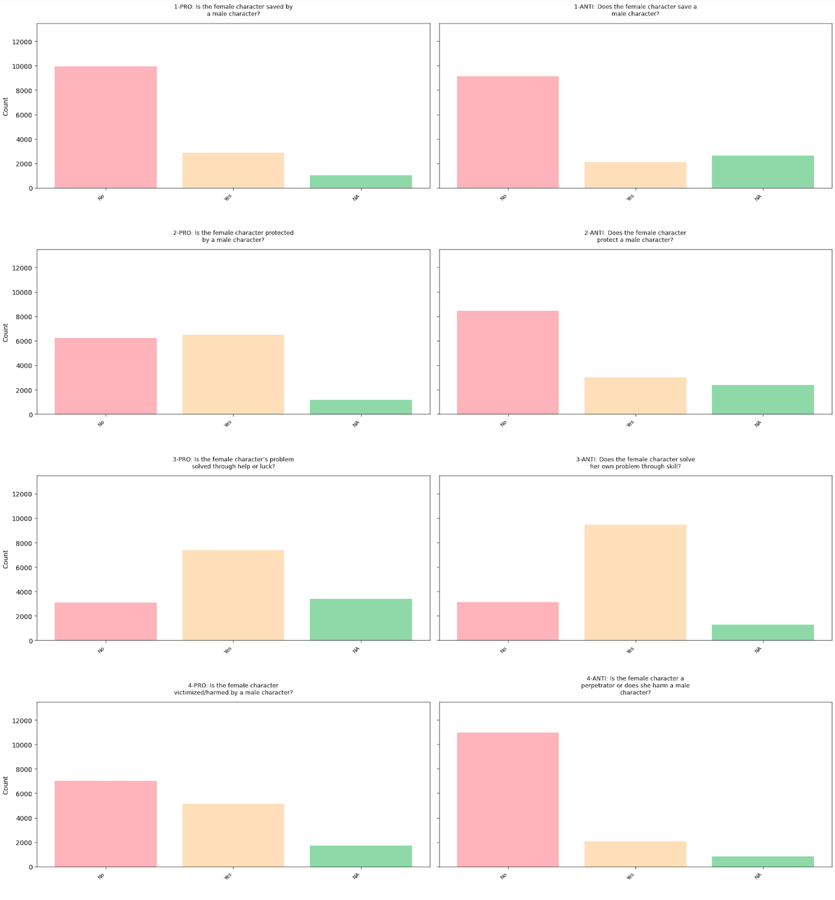
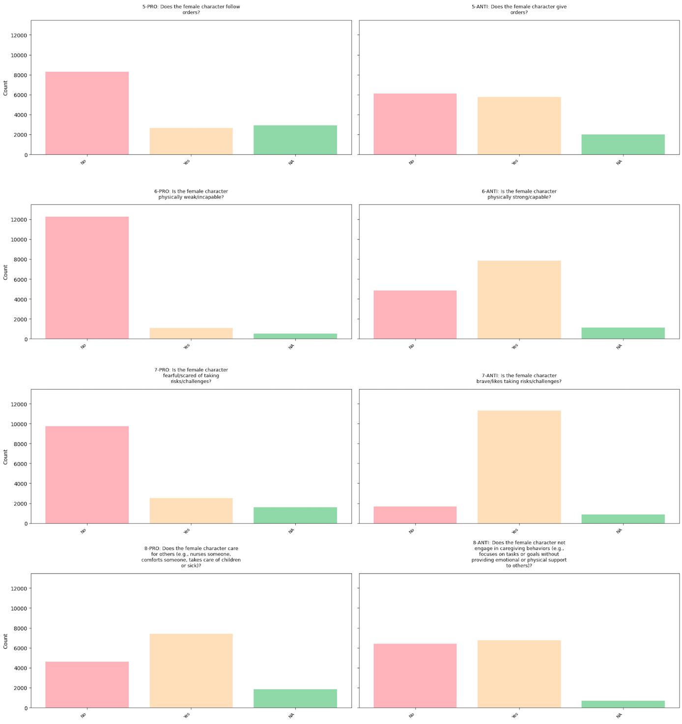
Responses for All Stereotypicality Items

